**KOLORSTONE: ACCURATE COLOR DETECTION TOOL**

Submitted in complete fulfillment of the requirements of the degree of

**BACHELOR OF ENGINEERING**

In

**INFORMATION TECHNOLOGY**

By

**KAUSHIK VAPIWALA (36)**

**AMAN GUPTA (10)**

**SANJIT KOLAPRATH (20)**

UNDER THE GUIDANCE OF

**Fr. Dr. John Rose S.J**

(Prof. Department of Information Technology)



+

**DEPARTMENT OF INFORMATION TECHNOLOGY**

**XAVIER INSTITUTE OF ENGINEERING**

**University of Mumbai**

**2017 – 2018**

**TABLE OF CONTENTS**

|  |  |  |
| --- | --- | --- |
| **SR.NO** | **TOPIC** | **PAGE**  **NO.** |
| I | LIST OF FIGURES | 1 |
| II | ABSTRACT | 2 |
| 1. | INTRODUCTION   * 1. PROBLEM DEFINITION   2. RELEVANCE OF THE PROJECT   3. SCOPE OF THE PROJECT | 3  3  4  5 |
| 2. | REVIEW OF LITERATURE | 6 |
| 3. | SYSTEM DESIGN  3.1 DESIGN CONSIDERATION  3.1.1 ALGORITHM  3.1.2 UML | 12  13  15  16 |
| 4. | IMPLEMENTATION  4.1 SYSTEM MODULES  4.2 S/W AND H/W REQUIREMENTS  4.3 IMPLEMENTATION PROCESS | 18  18  20  21 |
| 5. | TESTING  5.1 TESTING CASES | 24  24 |
| 6. | RESULTS AND DISCUSSIONS | 25 |
| 7. | CONCLUSION | 30 |
| 8. | REFERENCES AND PUBLICATIONS | 32 |

**LIST OF FIGURES**

|  |  |  |
| --- | --- | --- |
| **SR NO.** | **FIGURE** | **PAGE NO.** |
| 3.1 | Arduino | 12 |
| 3.2 | Bluetooth Module | 12 |
| 3.3 | Colour Sensor | 12 |
| 3.4 | Arduino Circuit Diagram | 13 |
| 3.5 | Connection Snapshot of the Board with the module | 13 |
| 3.6 | Connection Snapshot of the Board with the colour sensor | 14 |
| 3.7 | UML Diagram(Activity Diagram) | 16 |
| 6 | Snapshot of System Modules | 19 |

ABSTRACT

In a time where everything is going digital, right from an app to withdraw money or to purchase any household items it is a prime objective to increase the digitization of every activity so as to ease out the human work. The profession of people especially interior designers, architects, home decorators or artists involves a lot of heavy swatches which are to be carried from place to place. Furthermore, it is not feasible to record a colour at one place and reproduce the exact same colour with the exact properties at another place. "KolorStone" an app that will be linked with a hardware tool will eliminate such issues. The hardware tool is a sensor that, when pointed at any specific object, will eliminate every other sunlight that can possibly infiltrate and distort the actual colours on the object. The hardware tool will be programmed on an Arduino board and will be connected to the Android device using a Bluetooth module. The unadulterated colour that will be fetched by the hardware device will be given to the Android app which will first store the specifics of the colours the RGB code, CMYK code, HSL, HSI, HSV and HSB values in the database for any further use at any time needed. The app will further display the colour fetched by the device and will provide the corresponding shades that will begin from black (being the darkest shade of any colour) to white (being the lightest shade of any colour). The app will even provide a feature to compare any two colours and choose the one required by the end user. Thus, it will enable the designers to keep a track of the colours detected by them and eliminates the need of carrying different swatches and other heavy material since every piece of data will henceforth be collected by the app thereby making it more convenient for the end users and replace the old tradition with a digital one.

**CHAPTER 1**

**INTRODUCTION**

**1.1 PROBLEM DEFINITION**

* It is essential for interior designers and architects to have accurate colours. They require accurate. colours to the point to render digital drawings. Detecting accurate colours have always been a tedious task.
* Currently, there are two methods implemented by creative professionals. First, they judge and estimate the definitions of colours by their experience and then scan through colour wheel to get the exact colour. The major con of this method is that it is time-consuming and it is not possible for a beginner in that field to have such a kind of experience. Second, the creative professionals are always seen to carry catalogues of colour shades and definitions. These catalogues usually lead them to accurate colours but are often bulky to carry around. In addition to that, this solution is very costly.
* It is important to minimise the complexity involved and digitize the whole process. This will enable people in the creative professionals to work efficiently without having to bother about inefficiency and cons of the current methods. The project will have a set of hardware and software application which will work coherently to give required results.

**1.2 RELEVANCE OF PROJECT**

It is the areas where our implemented project can be employed, and which in turn can turn out as fruitful applications in various areas of life. The project can be related it to as a” Brick Solver” agent, which can help people separate out things based on the colour of the commodity. It can serve various areas such as:

1) Avoids separation of medicines in pharmaceutical industries.

2) To separate vegetables according to their colour.

3) Separating raw coffee beans in the manufacturing industries.

4) Kitchen cabinet manufacturers can use it to control the stain colour of the components.

5) Different artist/creative’s team can use it instead of carrying the huge colour pallets for taking out the name/colour value of the colour.

6) It would be helpful to some colour blind people/partially sighted people to sense the colour they are looking out for.

7) It can also serve as a tray which differentiates different shades of colour from the same colour.

**1.3 SCOPE OF THE PROJECT**

This project will develop and deliver a set of hardware and software. The hardware will fetch colours from a surface and send it to the software. The software includes a mobile application which will fetch data from the hardware and display it to the user. Moreover, the software will have additional features like combining two colours and displaying the resulting colour. In addition to that, the application will give information about the colour in different colour definitions like CMYK, RGB and HEX. Furthermore, the software will suggest similar colours to the detected colours. The application is lightweight and easy to maintain.

The project will have facilities such as displaying colours in different colour definitions. Moreover, two colours can be mixed to get resultant colour. In addition to that, there will be a colour wheel which will enable the user to have all the colours available in the spectrum and display information about it. Furthermore, the project will also display similar colours to the detected colours.

**CHAPTER 2**

**REVIEW OF LITERATURE**

One can assume that the goal of content-based image retrieval is to find images which are both semantically and visually relevant to users based on image descriptors. These descriptors are often provided by an example image--the query by example paradigm. The CBIR system used in this work is an application of the system developed for modeling the joint probability of image region features and associated text.

It is not necessary to train the model on both text and image data and use two variants of the model one where both text and image data is used, and one where only image data is used. To evaluate CBIR systems a subject with a query and corresponding result image pairs. The subject evaluates each pair as either “undecided”, “poor match”, “faint match”, or “good match”. Thus evaluating the “query by image example” paradigm

The images are represented by a set of low-level features related to their structure and colour distribution. Those descriptions are fed to a battery of image classifiers trained to evaluate the membership of the images with respect to a set of 14 overlapping classes. Packing together the scores vectors of pro semantic features are obtained, and used to index the images in an image retrieval system. The result shows that the use of pro semantic features allows for a more successful and quick retrieval of the query images There are other fields in medicine which typically have large medical image archives.

In particular, a huge amount of figures, graphs, images, and case examples is published in scientific literature, and the number of scientific journals that are published electronically is increasing. So to evaluate and estimate the impact of state-of-the-art medical CBIR integrated with text-based searches for retrieval of scientific literature. That is, investigate the use of bitmaps within the journal articles as additional information for retrieval, which reduces error rate of retrieval by 4.5 %.

Features that most method focuses on are colour, shape, and texture. For colour, a significant improvement over the RGB-colour space use of opponent colour representation uses the opponent colour axes (R-G, 2B-R-G, R+G+B) is one way to represent colour of an image. There is also a method called Colour Predominance Method which scans the image and replaces each pixel colour with the new RGB colour list, gave an example indexing using texture where an image is indexed by a vector (w1, w2, w3, w4, w5, w6) representing the estimated proportion of texture where it is the proportion of pixels classified with texture they are introducing indexing using Intermediate Features.

Several methods for retrieving images on the basis of colour similarity have been described in the literature, but most are variations on the same basic idea. Each image added to the collection is analysed­­­­­­­­ to compute a colour histogram which shows the proportion of 6 pixels of each colour within the image. The colour histogram for each image is then stored in the database.

**1.)M. Frank, et al., "High-speed industrial colour and position sensors," Electronic Imaging'99, pp. 50-57, 1999.**

The paper presents a colour sensor system that can process light reflected from a surface and produce a digital output representing the colour of the surface. The end-user interface circuit requires only a 3-bit pseudo flash analog-to-digital converter (ADC) in place of the conventional/typical design comprising ADC, digital signal processor, and memory.

For scalability and compactness, the ADC was designed such that only two comparators were required regardless of the number of colour/wavelength to be identified. The complete system design has been implemented in hardware (breadboard) and fully characterized. The ADC achieved less than 0.1 LSB for both INL and DNL. The experimental results also demonstrate that the colour sensor system is working as intended at 20 kHz while maintaining greater than 2.5 ENOB by the ADC.

This work proved the design concept and the system will be realized with integrated circuit technology in future to improve its operating frequency.

The principle of detection embedded in our colour sensor system is based on reflectance property of a coloured surface, as illustrated in. When a white light is shined on a surface, the surface will reflect a specific spectrum while absorbing all the other spectra.

For example, a white light focused onto a red surface is reflected as red. The reflected red light impinges on the light transducer producing a corresponding output voltage that is typical of the reflected red colour. By interpreting this output voltage using an interface circuit, the colour can be determined.

**2.) DLindaHoltzschue, Understanding Colour: An introduction for Designers.**

This paper describes the new technique used for the RGB colour detection. The proposed technique illustrate the new methodology that can be used for the primary colour detection and applications in various industries. It is a colour sensor that senses mainly red green and blue colours. This colour sensor is designed by basic elements like primary colour LED and light sensing devices like LDR or photodiode. The basic principal of working is reflectivity of the light emitted by the LEDs from the object under test.

The present technique used in industry is based on the image processing of the particular object. For capturing of the image of object digital camera is required which is very expensive. The algorithm used for such type of sorting become complex.

Another technique detects the colour on the basis of wavelength. As the range is variable there is lots of variation in the colour identification. Related these sorting technique the most probable issue is the cost of the sensor. To overcome the drawback a sensor is invented which mainly works on the measuring intensity of light. The sensor basically consists of the primary LEDs (i.e. .red, green and blue) and the light sensing device that may be LDR (light dependent register) or Photodiode. The overall sensor is controlled by the microcontroller unit; the detected colour is displayed on LCD. The overall colour detector unit consists of the two subunits, mainly called sensor and display subunits.

**3.) A High-precision Colour Sensor for the B/M9000VP System.**

In the paperboard market, which is expected to grow in various countries, demand for paper colour control has recently been increasing. To satisfy this demand, Yokogawa has developed a new colour sensor for the B/ M9000VP system, a measurement, and control system for both paper and coating machines. The B/M9000VP is an online paper quality measuring and controlling system with various sensors mounted on a dedicated frame head, including such sensors as for basis weight, moisture, paper thickness and ash content. The frame head moves over the surface of the paper in the process. The new colour sensor is one of the sensors mounted on the frame head.

A colour sensor for a measurement and control system for paper machines and coating machines (hereafter, such a system is referred to as the “B/M system,” where B/M stands for basis weight and moisture) uses a measurement principle similar to that of a usual spectrocolourimeter. However, there exist some issues specific to online sensors used for the papermaking process. The head unit of a B/M system keeps moving over the surface of paper during processing. Therefore, sensors on the head unit are exposed to vibrations caused by this mechanical motion, which result in a harsh condition for a colour sensor composed of precision optical components. Even if there is a problem only with the colour sensor, a measurement cannot be interrupted for inspection, as not only a colour sensor but also other sensors such as basis weight, moisture, paper thickness and ash sensors are mounted on the head. Thus failures and replacements of any components of the colour sensor used for a B/M system should be eliminated as much as possible. It is also desirable that the sensor status be able to be checked without interrupting the measurement.

**4.)X. Fang, K.S. Hsiao, V. P. Chodavarapu, A.H. Titus, and A.N. Cartwright, “Colourimetric porous photonic bandgap sensors with integrated CMOS colour detectors,” IEEE Sensors Journal, vol. 6, no. 3, pp. 661-667, June 2006.**

An intelligent colour sensing system has been developed. The developed system is capable of the measurement of colour for building a wall. The colour sensing system is implemented using Arduino processing unit with white Light Emitting Diodes (LEDs) and programmable Complementary Metal Oxide Semiconductor (CMOS) colour sensor. The output of the colour sensor is directly proportional to the light intensity of incident light and calibrated to measure the primary colours such as red, green, and blue. A graphical user interface (GUI) is developed for display the colour of the wall. The calibration of the Intelligent Colour Sensing (ICS) system has been implemented successfully. The ICS system is easy to operate, energy efficient, and accurate.

Nowadays the building colour affects the human moods, feelings and shows the human personality. Therefore, the selection of wall colour is important to keep peace, and unity in life. Presently, several researchers have published work on colour sensing systems to detect the colour of objects. The inferences of literature are discussed herein. Fang et al.reported colourimeter sensor based on polymer material and complementary metal oxide semiconductor (CMOS) technology. They used buried double-junction and triple-junction structure to detect the reflected light from the polymer material and acetone vapour. Fu et al. proposed the neuromorphic light sensor based on retina-like principle, buried double-junction, and AMI semiconductor technology. They focused on colour change intensity change disambiguation (CCICD) and colour detection. Sahu et al. developed colour detector for a laser beam in the high radiation zone. They used an array of light dependent resistors and neural network algorithm for identifying the colour of the laser beam. Polzer et al. presented bipolar junction transistor (BJT) and the complementary metal oxide semiconductor (CMOS) transistor based colour sensor without any filter layer.

They focused on the penetration depth and absorption coefficient in silicon to measure the wavelength of incident light. Al-Bahadly et al. developed a colour detector for car repainting based on RGB colour model and graphical user interface. The Graphical User Interface (GUI) is used to calculate the percentage of primary colours (red, green, and blue) in the captured images. Yurish et al. developed the optoelectronics colour sensor system. The authors used light-to-frequency sensor, Schmitt trigger, and Universal Sensor and Transducers Interface (USTI) circuit for the high-speed light-to-digital converter. Assaad et al.Li et al. presented colour sensing and controlling system. The researchers interfaced Light Emitting Diode (LED) arrays, LED lamps, current sensing path and current regulator with a microcontroller.

|  |  |  |  |  |
| --- | --- | --- | --- | --- |
| SR.NO | Author | Year | Paper Name | Content relevant to project |
| 1. | M. Frank | 1999 | High-speed industrial colour and position sensors | Sensing used in industry using complex method. |
| 2. | DLindaHoltzschue | 2001 | Understanding Colour: An introduction for Designers | An introduction of colour for the information regarding its use with them. |
| 3. | B/M9000VP System | 2002 | High-precision Colour Sensor | Detection of colour of building walls. |
| 4. | X. Fang, K.S. Hsiao | 2006 | Colourimetric porous photonic bandgap sensors with integrated CMOS colour detectors | Uses photonic bandgap sensors with the help of CMOS detectors. |

**CHAPTER 3**

**SYSTEM DESIGN**

System design is the process of defining the architecture, components, modules, interfaces, and data for a system to satisfy specified requirements. Systems design could be seen as the application of systems theory to product development.

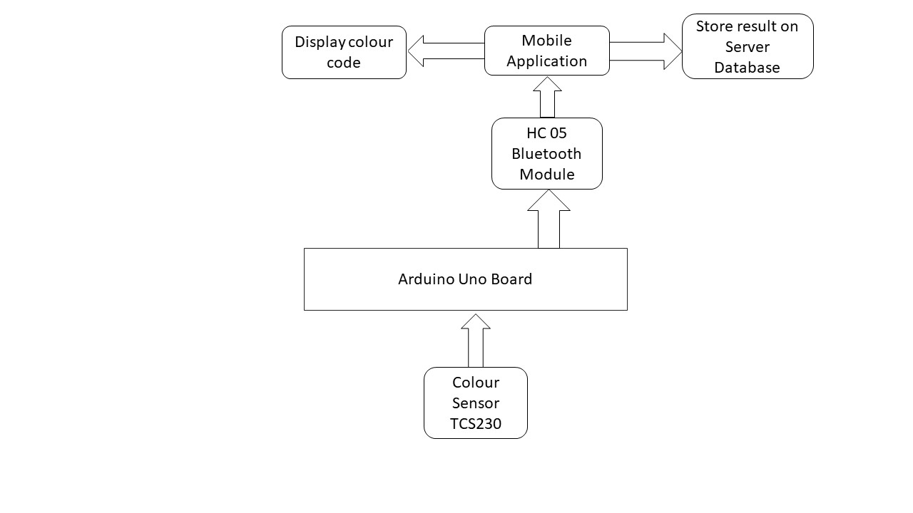

**3.1 DESIGN CONSIDERATION**

We are having majorly 3 components in our project namely 1. Arduino 2. Bluetooth Module 3. Colour Sensor: -

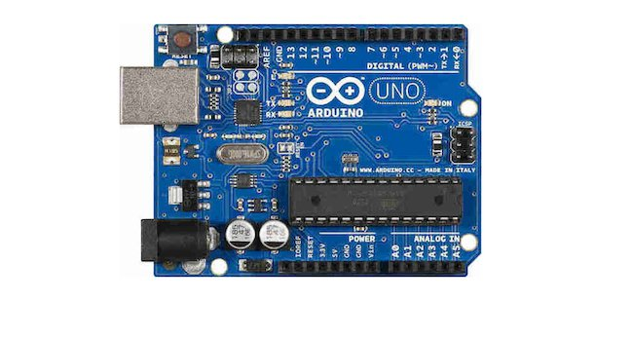

Fig 3.1.Arduino

The project uses Arduino Uno board which works on 16 MHz frequency. It consists of 13 digital and 13 analog pins. It requires 5V and 0.5 A to run.

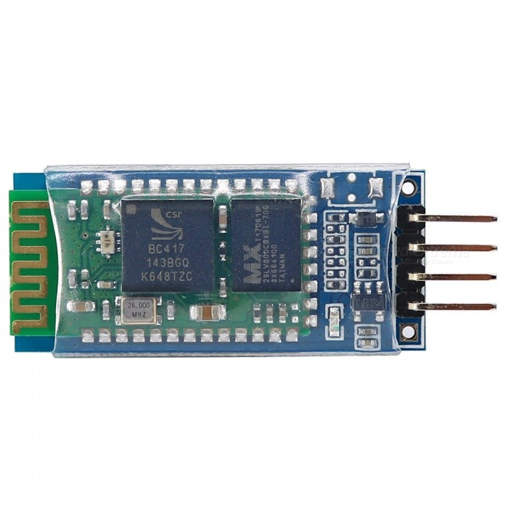

Fig 3.2.Bluetooth Module

The project uses HC05 module to function. It requires 3.3V of power.

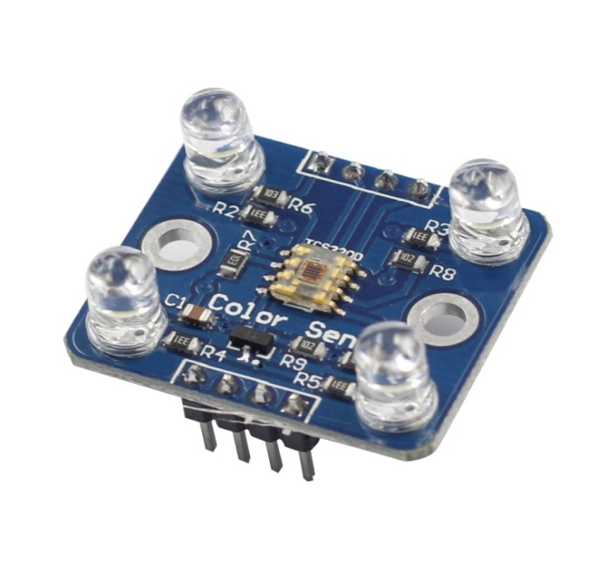

Fig 3.3.Colour Sensor

The project uses TCS3200 colour sensor. There are 8 pins in the sensor of which four define colour and frequency scaling. The sensor provides 4 LEDs which help in isolating the detection point.

**The Circuit Diagram for the Arduino Board is :-**

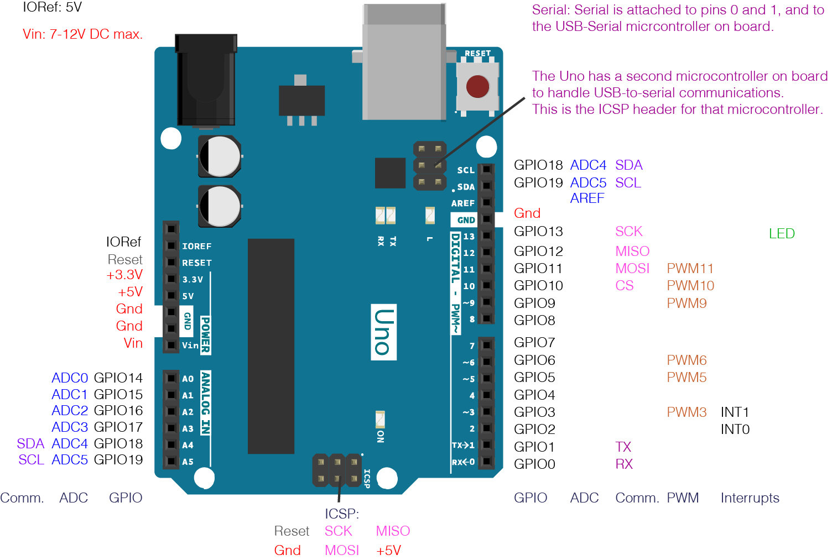

Fig 3.4.Arduino Circuit Diagram

**The Connection Snapshot of the Board with the module is:-**

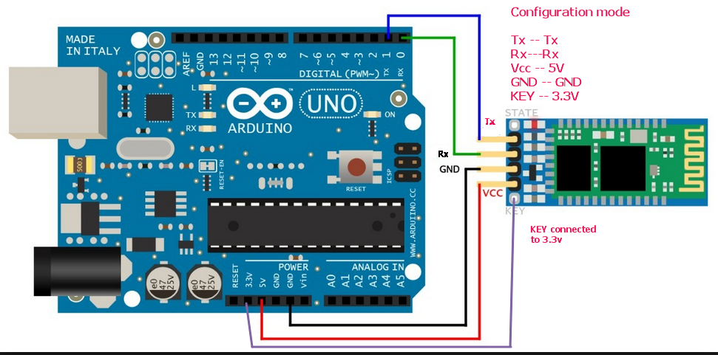

Fig.3.5 Connection snapshot of the board with the module

**The Connection Snapshot of the Board with the colour sensor is:-**

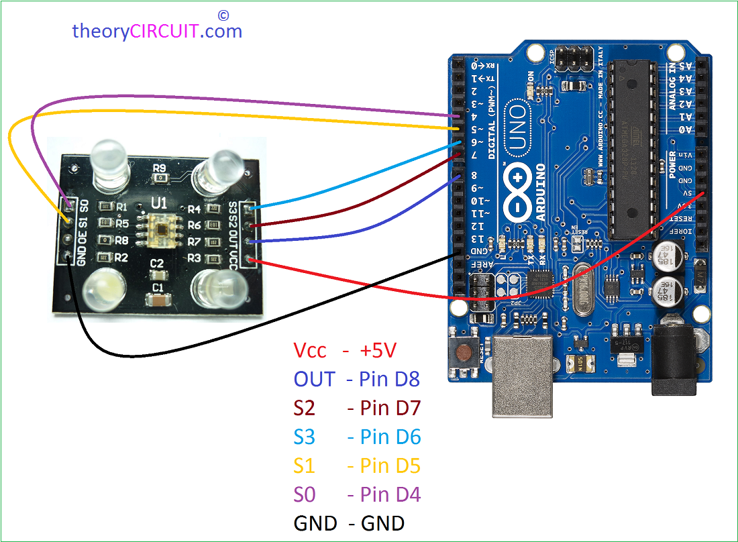

Fig.3.6 Connection snapshot of the board with the colour sensor

**3.1.2 UML DIAGRAMS:**

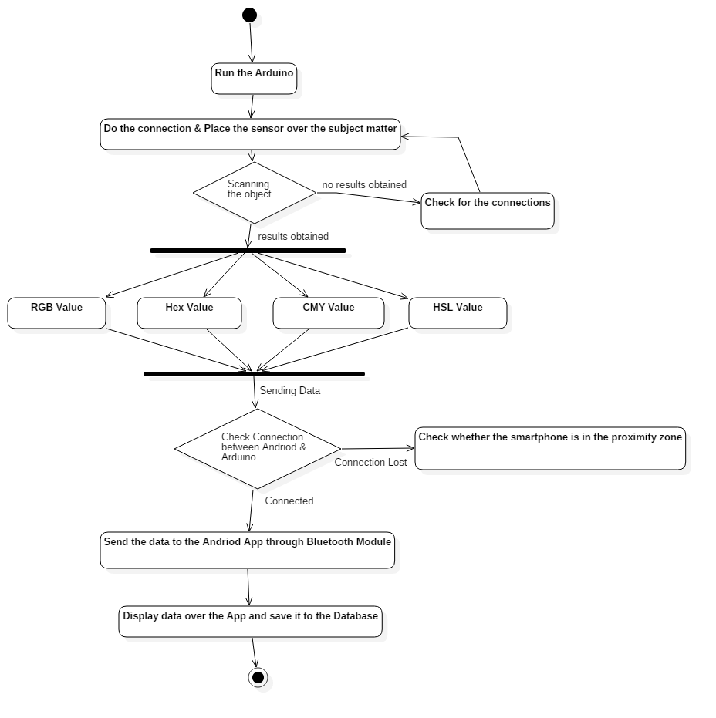

Fig.3.7. UML Diagram (Activity Diagram)

The uml diagram here shows the flow of each activity since the beginning, from the start of hardware(Arduino), to check the connection and the detection of colour in the android app.

**CHAPTER 4**

**IMPLEMENTATION**

**4.1 SYSTEM MODULES**

This system is having 5 Modules:

1. **User Registration/ Login**
2. **Connect to Bluetooth**
3. **Detect Colour**
4. **Mix Colour**
5. **Colour Picker**

**Description:**

* **User Registration/ Login:**

User who needs to use the app must first login in the application since the data that the user would store would be unique to every individual and provides more privacy.

* **Connect to Bluetooth:**

The user after logging in must connect his/her smartphone to the hardware device using the app via Bluetooth.

* **Detect Colour:**

The UI will provide the user with a rectangular area which will display the captured colour from the desired object.

* **Mix Colour:**

User can mix two colours of his/her choice by selecting them from the option given.

* **Colour Picker.**

The colour wheel provides the user with different shades of a single colour to enable more accurate results.

**4.2 Hardware and Software Requirements**

**Arduino Software IDE (Sketch)**

Arduino is an open-source electronics platform based on easy-to-use hardware and software. [Arduino boards](https://www.arduino.cc/en/Main/Products) are able to read inputs - light on a sensor, a finger on a button, or a Twitter message - and turn it into an output - activating a motor, turning on an LED, publishing something online. You can tell your board what to do by sending a set of instructions to the microcontroller on the board. The open-source Arduino Software (IDE) makes it easy to write code and upload it to the board. It runs on Windows, Mac OS X, and Linux. The environment is written in Java and based on Processing and other open-source software. This software can be used with any Arduino board.

Arduino board designs use a variety of microprocessors and controllers. The boards are equipped with sets of digital and analog [input/output](https://en.wikipedia.org/wiki/Input/output) (I/O) pins that may be interfaced to various expansion boards (*shields*) and other circuits. The boards feature serial communications interfaces, including [Universal Serial Bus](https://en.wikipedia.org/wiki/Universal_Serial_Bus) (USB) on some models, which are also used for loading programs from personal computers. The microcontrollers are typically programmed using a dialect of features from the programming languages [C](https://en.wikipedia.org/wiki/C_(programming_language)) and [C++](https://en.wikipedia.org/wiki/C%2B%2B). In addition to using traditional compiler toolchains, the Arduino project provides an [integrated development environment](https://en.wikipedia.org/wiki/Integrated_development_environment) (IDE) based on the [Processing](https://en.wikipedia.org/wiki/Processing_(programming_language)) language project.

**Android Studio**

Android Studio is the official Integrated Development Environment (IDE) for Android app development, based on IntelliJ IDEA. On top of IntelliJ's powerful code editor and developer tools, Android Studio offers, even more, features that enhance your productivity when building Android apps, such as:

* A flexible Gradle-based build system
* A fast and feature-rich emulator
* A unified environment where you can develop for all Android devices
* Instant Run to push changes to your running app without building a new APK
* Code templates and GitHub integration to help you build common app features and import sample code
* Extensive testing tools and frameworks
* Lint tools to catch performance, usability, version compatibility, and other problems.

**5.2 HARDWARE**

* **Arduino**

Arduino is an open-source computer hardware and software company, project, and user community that designs and manufactures single-board microcontrollers and microcontroller kits for building digital devices and interactive objects that can sense and control objects in the physical world. The project's products are distributed as open-source hardware and software, which are licensed under the GNU Lesser General Public License (LGPL) or the GNU General Public License (GPL), permitting the manufacture of Arduino boards.

* **Colour Sensor**

This Colour Sensor is a complete colour detector, including a TCS230 RGB sensor chip and 4 white LEDs. The TCS230 can detect and measure a nearly limitless range of visible colours.

* **Bluetooth Module**

HC‐05 module is an easy to use Bluetooth SPP (Serial Port Protocol) module, designed for transparent wireless serial connection setup. The HC-05 Bluetooth Module can be used in a Master or Slave configuration, making it a great solution for wireless communication. This serial port Bluetooth module is fully qualified Bluetooth V2.0+EDR (Enhanced Data Rate) 3Mbps Modulation with complete 2.4GHz radio transceiver and baseband.

* **Smartphone (For Android App)**

A Smartphone is a handheld personal computer with a mobile operating system and an integrated mobile broadband network connection for [voice](https://en.wikipedia.org/wiki/Telephone_call) and data communication. Smartphone are typically pocket-sized (as opposed to [tablets](https://en.wikipedia.org/wiki/Tablet_computer), which are much larger than a pocket), and have the ability to place and receive voice and video calls, exchange text messages, and access the Internet through cellular networks or [Wi-Fi](https://en.wikipedia.org/wiki/Wi-Fi).

**CHAPTER 5**

**ALGORITHM**

**The Algorithm supporting our proposed project is as follows:**

**Conversion from RGB colour to hexadecimal colour code:-**

**RGB colour**

The RGB colour is a combination of Red, Green and Blue colours:

(*R*, *G*, *B*)

The red, green and blue use 8 bits each, which have integer values from 0 to 255.

So the number of colours that can be generated is:

256×256×256 = 16777216 = 100000016

**Hex colour code**

Hex colour code is a 6 digits hexadecimal (base 16) number:

RRGGBB16

The 2 left digits represent the red colour.

The 2 middle digits represent the green colour.

The 2 right digits represent the blue colour.

**RGB to hex conversion**

1. Convert the red, green and blue colour values from decimal to hex.
2. Concatenate the 3 hex values of the red, green and blue together: RRGGBB.

Example #1

Convert red colour (255,0,0) to hex colour code:

*R* = 25510 = FF16

*G* = 010 = 0016

*B* = 010 = 0016

So the hex colour code is:

*Hex* = FF0000

## RGB to CMYK conversion formula

The R,G,B values are divided by 255 to change the range from 0..255 to 0..1:

R' = R/255

G' = G/255

B' = B/255

The black key (K) color is calculated from the red (R'), green (G') and blue (B') colours:

K = 1-max(R', G', B')

The cyan color (C) is calculated from the red (R') and black (K) colours:

C = (1-R'-K) / (1-K)

The magenta color (M) is calculated from the green (G') and black (K) colours:

M = (1-G'-K) / (1-K)

The yellow color (Y) is calculated from the blue (B') and black (K) colours:

Y = (1-B'-K) / (1-K)

**CHAPTER 5**

**TESTING**

As the project is on bit large scale, we always need testing to make it successful. If each components work properly in all respect and gives desired output for all kind of inputs then project is said to be successful. So the conclusion is-to make the project successful, it needs to be tested.

The testing done here was Functional Testing checking whether the hardware tool detected the colors. The code for the new system has been written on Sketch, an IDE to run the code for Arduino board, with the test cases being displayed on the app. System has been checked and verified with different colour codes and gives almost the desired results.

The flow of the forms has been found to be very much in accordance with the actual flow of data.

**5.1 TEST CASES**

Table 1: Test Cases

|  |  |  |  |  |
| --- | --- | --- | --- | --- |
| Sr.No. | Colour to be detected | Actual Output | Expected Output | Interpretation  (R,G,B) |
| 1. | Red | Red | Red | 255,0,0 |
| 2. | Green | Green | Green | 0,255,0 |
| 3. | Yellow | Yellow | Yellow | 255,255,0 |
| 4. | Blue | Blue | Blue | 0,0,255 |
| 5. | White | White | White | 255,255,255 |
| 6. | Black | Black | Black | 0,0,0 |

**CHAPTER 6**

**RESULTS AND DISCUSSION**

**SNAPSHOTS OF MODULES:**

1. The home page

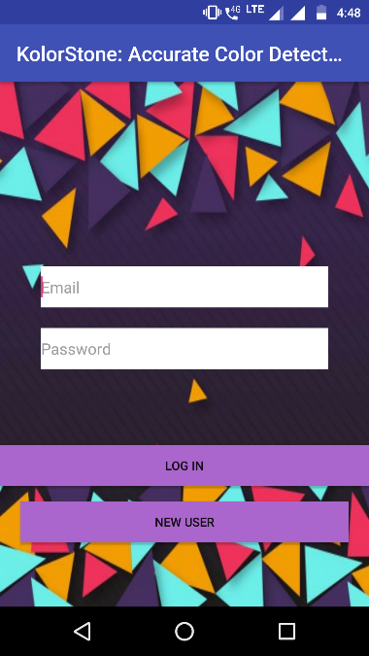

Fig.6.1 Home page

2.Connection of app with Bluetooth Module.

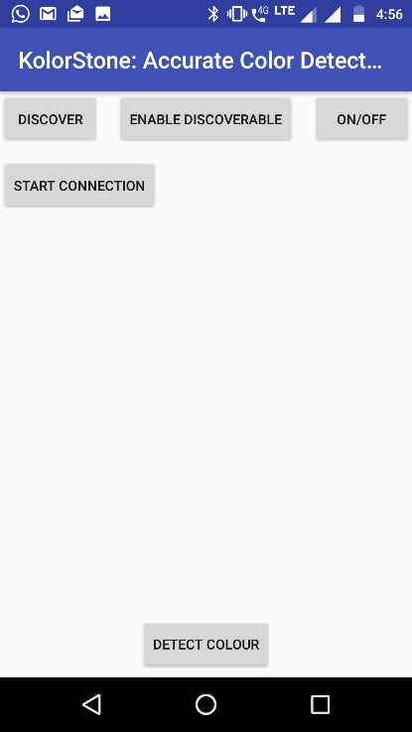

Fig. 6.2. To connect to hardware

1. UI of App after user has logged in the app.

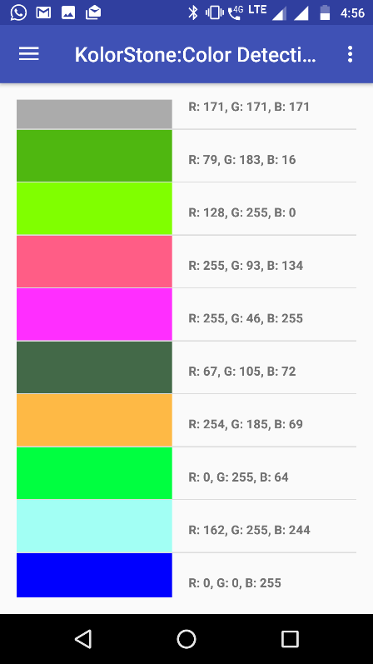 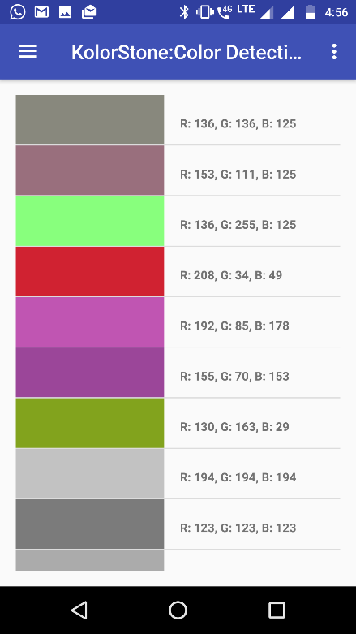

Fig.6.3. Recently sensed colours shown.

1. UI to detect Colour.

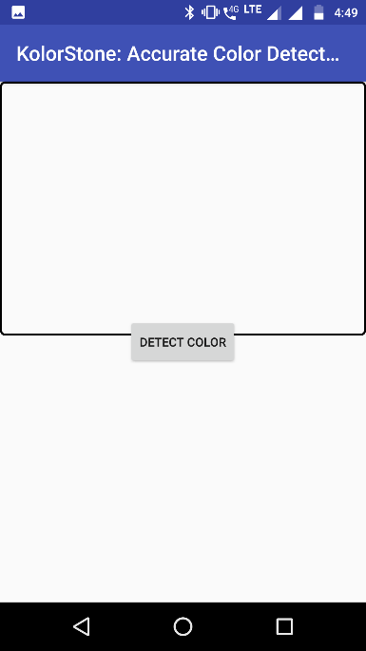

Fig 6.4 User detects the colour of the selected object.

1. UI for a user to mix colours:

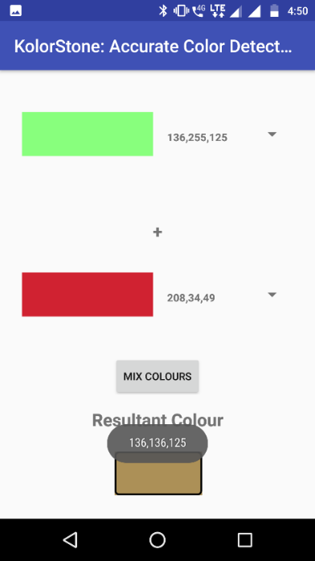

Fig 6.5 User can manually mix two colours.

1. Colour wheel to manually pick desired colour.

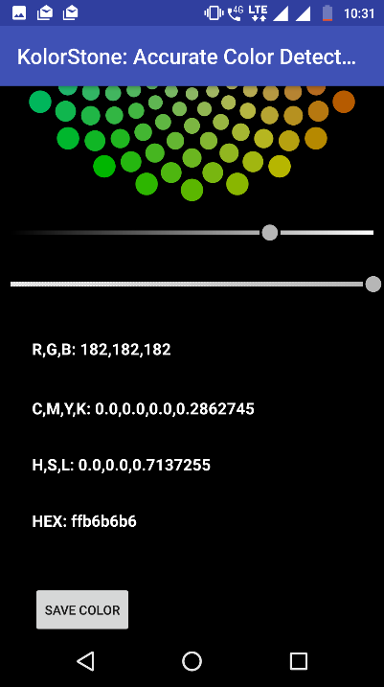

Fig.6.6. Colour Wheel providing RGB values.

1. The tool to detect colour.

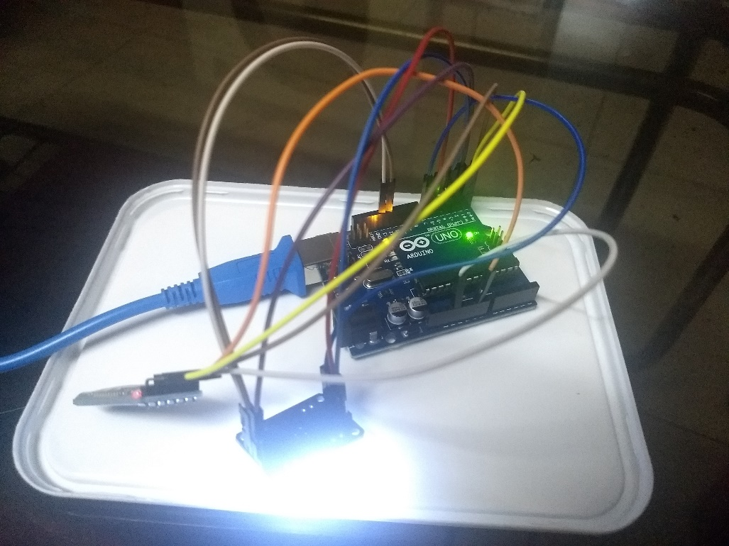

Fig.6.7

1. Arduino program giving desired output.

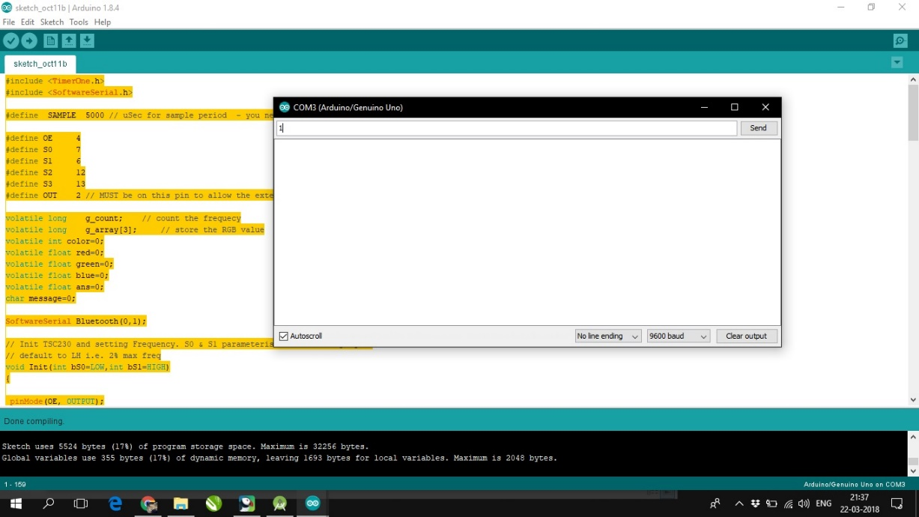

Fig.6.8

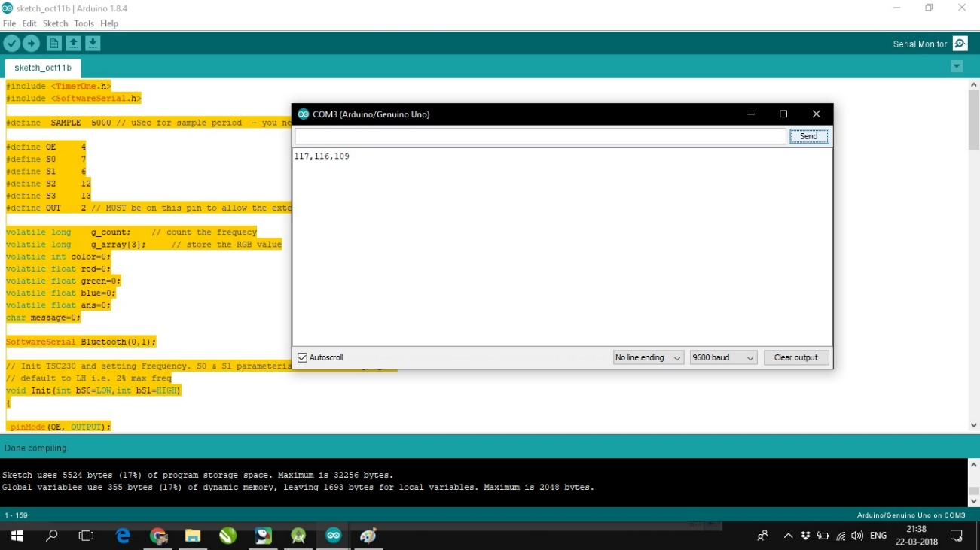

Fig.6.9

**CHAPTER 7**

**CONCLUSION and FUTURE SCOPE**

**Conclusion:**

**Advantages:**

* The colour provided by the tool is unaltered from any external factors.
* Since the device is tiny, designers can carry it along with them to different field of work.
* The colours are stored on a database, eliminating the actual use of physical storage.
* Designers can mix colours on the app itself rather than physically doing it.
* The product is cost efficient since all the tools are readily available and open source.

**Disadvantages:**

* The tool is only operable with Android OS.
* The colour sensor component is delicate and might get damaged in undefined circumstances.

**Applications:**

* This system is specially designed for interior designers, graphic designers, poster makers where exact use of colours is required.
* The system can also be implemented in different factories to ensure the product colour remains the same.

**System is:**

1. Easy Accessibility:

Colours can be easily accessed by the user on a single click.

1. User Friendly:

The system has a special user friendly app designed to interact with users.

1. Efficient and reliable:

The colours detected are quite similar to the actual colour present in the real world thus it makes it easier for the clients to work on them. Once detected, the colours are stored in a database which can only be accessed by the logged in user.

1. Easy maintenance:

The system consists of a hardware integrated tool which is portable and can sustain itself for long periods thus maintenance cost is minimum. The tool is fast and robust providing the information required on a single go, thus improving the traditional work process of the user by a major step.

**FUTURE SCOPE:**

The project here only works on Android platform predominantly. Moreover, the distribution of the application needs to be extended to iOS. The hardware tool manages to detect the colour of solid objects, hence, can be further implemented to detect the colour of textured surfaces. The project doesn’t provide any resultant effect on transparent objects.

**CHAPTER 8**

**REFERENCES AND PUBLICATION**

**8.1 TECHNICAL PAPERS REFERENCES**

1. <https://www.adafruit.com/product/1334>

2. <https://www.sparkfun.com/products/retired/11195>

3. [https://www.sick.com/in/en/registration-sensors/colour-sensors/c/g113666](https://www.sick.com/in/en/registration-sensors/color-sensors/c/g113666)

4. [http://ams.com/eng/Products/Light-Sensors/Colour-Sensors](http://ams.com/eng/Products/Light-Sensors/Color-Sensors)

5. [http://howtomechatronics.com/tutorials/arduino/arduino-colour-sensing-tutorial-tcs230-tcs3200-colour-sensor/](http://howtomechatronics.com/tutorials/arduino/arduino-color-sensing-tutorial-tcs230-tcs3200-color-sensor/)

6. <https://www.allaboutcircuits.com/projects/control-an-arduino-using-your-phone/>

7. <https://www.hackster.io/user206876468/arduino-bluetooth-basic-tutorial-d8b737>

8. <https://www.youtube.com/watch?v=sXs7S048eIo>

* 1. **BIBLIOGRAPHY**

[1] http://ieeexplore.ieee.org/document/6997578/

[2] http://ieeexplore.ieee.org/document/6494433/

[3] https://playground.arduino.cc/uploads/Main/arduino_notebook_v1-1.pdf

[4] http://ieeexplore.ieee.org/document/5670781/

[5] https://developer.android.com/training/basics/firstapp/index.html

[6] https://www.youtube.com/watch?v=fCxzA9_kg6s

[7] https://howtomechatronics.com/tutorials/arduino/arduino-color-sensing-tutorial-tcs230-tcs3200-color-sensor/

[8] http://www.instructables.com/id/Connect-Arduino-Uno-to-Android-via-Bluetooth/

[9] https://www.youtube.com/watch?v=nMcZmrH27z8